**Seurat, Georges-Pierre (1859 –1891)**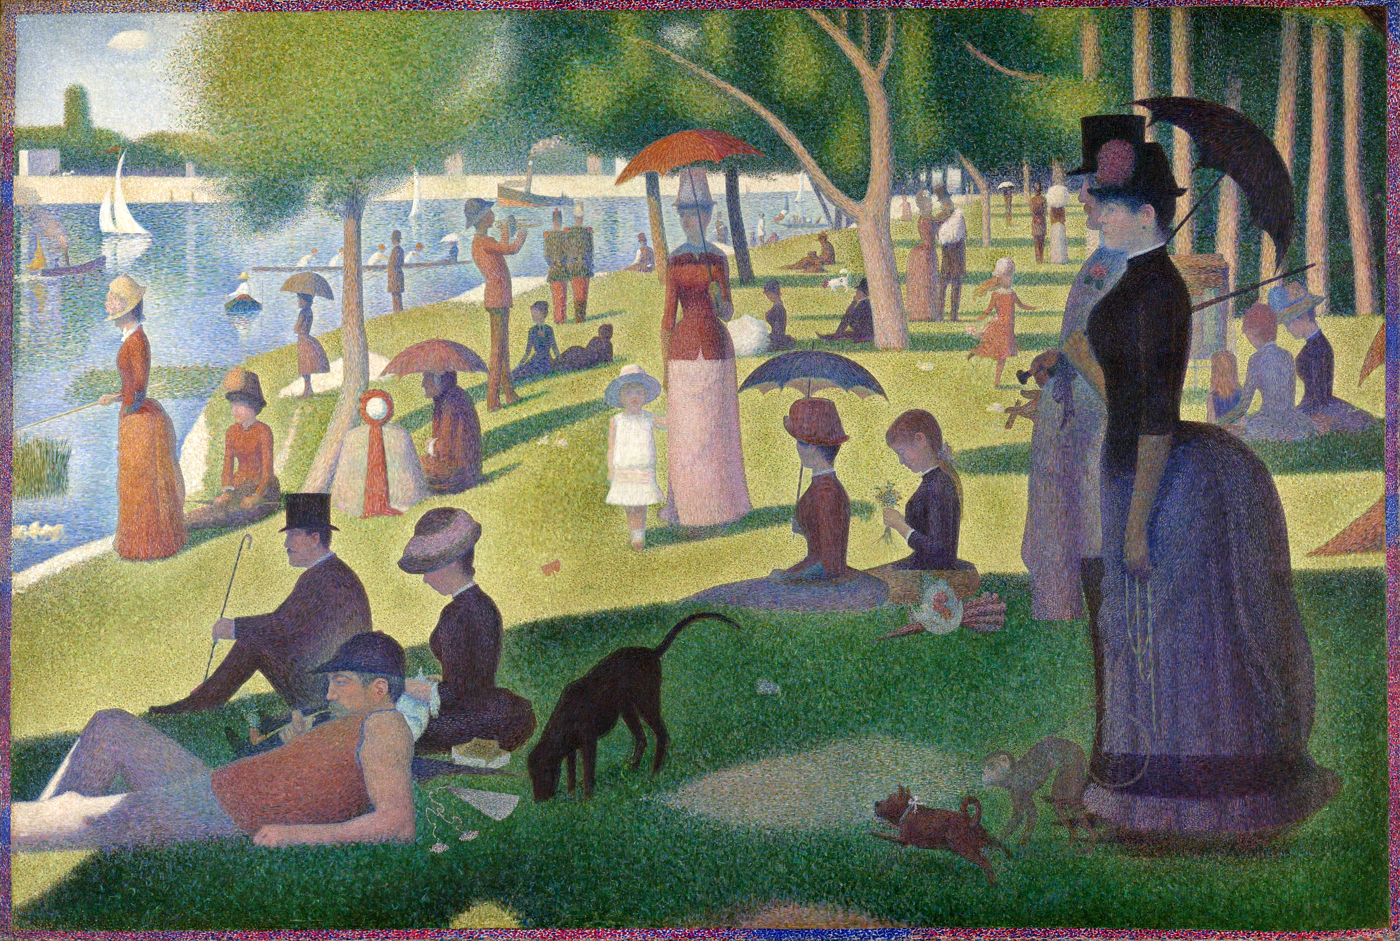

*Sunday Afternoon on the Island of La Grande-Jatte* (1884-86)

(currently in the Art Institute of Chicago)

Born in Paris in 1859 to a bourgeois family, painter and draughtsman Georges-Pierre Seurat enjoyed a brief but mature career as the leading French Neo-Impressionist. His invention of Divisionism (or ‘chromo-luminarism’), a painting technique grounded in science and the study of optics, challenged the spontaneity and fluidity of Impressionism, which by the 1880s had been largely subsumed by a capitalist gallery system. In 1886, at the eighth and final Impressionist exhibition, Seurat debuted his monumental *Sunday Afternoon on the Island of La Grande-Jatte* (1884-86), a “patient tapestry” of line and color that led the art critic and activist Félix Fénéon to coin the term *néo-impressionisme.* Equally shaped by the Renaissance frescoes of Piero della Francesca and the Baudelairean praise of the ephemerality of modern life, *La Grande-Jatte* symbolically closed a chapter in French painting. Seurat’s systematic aesthetic produced an indelible impact on fin de siècle artists such as Vincent van Gogh, Paul Gauguin, Henri de Toulouse-Lautrec, Henri Matisse, and later Pablo Picasso, Robert Delaunay, and André Breton’s Surrealism, firmly establishing him as integral to the twentieth-century avant-garde. and six major figure paintingsonly

Seurat’s father, Antoine-Chrysostome Seurat, an eccentric customs official who built his wealth by real estate speculation, and Parisian mother Ernestine Faivre, kept an apartment at 130 Boulevard de Magenta, although the artist saw little of his father, who had a separate residence. He remained closest to his mother and her relatives, receiving drawing lessons from his maternal uncle. Seurat memorialised his mother and the theme of domesticity in the tenebristic, conté crayon drawing *Embroidery* (1882–83). Modelled with dense tonal passages of velvety greys and blacks, the work evinces a mesmerising quality of light achieved by the withdrawal of pigment.

His formal training began in 1875 at the local art school with sculptor Justin Lequien, where he first drew from antique statuary. In 1878 he entered the École des Beaux-Arts, studying under Henri Lehmann, a disciple of Ingres, where he remained for approximately a year. Chafing against this sterile academic training, he then found himself studying paintings in the Louvre and in the new avant-garde Impressionist exhibitions (1874-1886). Greatly impressed by Ingres’s sculptural draftsmanship, Seurat held an equally firm admiration for the colouristic experiments of Rubens, Delacroix, the Barbizon School, and the Impressionists. An avid reader of art theory and history, he studied Charles Blanc’s influential *Grammaire des arts du dessin* (Grammar of the Arts of Design, 1867), which espoused the expressive values of line and colour, and the chemist Michel-Eugène Chevreul’s *De la loi du contraste simultané des couleurs* (On the Law of Simultaneous Contrast of Colours, 1839), a famous treatise analysing the difference between pigment and light.

On 29 July 1884 in Paris, Seurat, his soon-to-be disciple Paul Signac, Odilon Redon, and Albert Dubois-Pillet, among others, founded the Société des Artistes Indépendants in response to the repressive Salon. The inaugural December 1884 Salon des Indépendants showcased Seurat’s first major canvas, *La baignade à Asnières* (Bathers at Asnières, 1883-84), depicting working class men relaxing along the banks of the Seine in a northwest industrial suburb. Measuring two by three metres and based on nearly 25 drawings and *en plein air* oil sketches, the painting presented a conspicuous challenge to Impressionism’s liquid informality while maintaining its colouristic oppositions. Its scale signified a heroic monumentality at odds with its strikingly Modern subject matter, that is, the bucolic, quotidian pleasures of the proletariat.

Two years later, at the final Impressionist exhibition at 1 rue Lafitte, Seurat married the polarities of line and color in what became the iconic manifesto of his Neo-Impressionism, *La* *Grande Jatte.* He had spent 1884 and part of 1885 working on preparatory drawings for the penultimate canvas. Inspired as he was by the decorative panel paintings of another teacher, Pierre Puvis de Chavannes, Seurat sought contemporaneity in the mural-sized  *La Grande-Jatte*, a startling composition of “promenading moderns” that he based upon Phidias’s hieratic figures from the Parthenon Frieze. Conceived as a pendant to *Bathers*, *La Grande-Jatte* included fifty figures, men and women of different social classes relaxing in a riverside park opposite Asnières. A committed anarchist—like his colleagues Fénéon, Signac and Camille Pissarro—Seurat’s critique fulfilled the socialist demand for *vérité* (truth or sincerity), although this was often ignored by the public and critics, who focused on the painting’s admittedly meticulous and stunning surface appeal. Here, unlike the fugitive sensations of Impressionism, Seurat sought an ideal, permanent reality in which social justice and aesthetic harmony went hand in hand. Fénéon described the artist’s *mélange optique* (optical painting), whereby dotted brushstrokes (*pointillé*)recombined on the retina of the observer, resulting in a vibrating fusion of hue and light on the painted surface. *La Grande-Jatte* synthesized Seurat’s study of color theory—now shaped by Ogden Rood’s more up-to-date *Modern Chromatics* (1879)—with a profound consciousness of Classical rationality, conveyed by the static and schematic figures, and with a cool veracity that resolved a crisis in painting and opened the way to new possibilities.

Seurat’s Neo-Impressionism was propagated through the enthusiastic writings of Fénéon and Signac, who published *D’Eugène Delacroix au Néo-Impressionnisme* (1899) after his mentor’s death, revitalizing the movement among the nascent Fauvists and German Expressionists. In August 1890, Seurat penned a letter (never sent) in response to an inquiry from the journalist Maurice Beaubourg, in which he articulated critical aspects of Neo-Impressionism. Drawing upon traditional theories of art and the “experimental aesthetics” of his friend the mathematician, physicist, psychologist and art critic Charles Henry, Seurat put forth art as the harmonious analogy of both contrary and similar elements of tone, color, and line, asserting that under the influence of light and dark, such elements revealed specific correspondences with emotional states such as calm, gaiety, sadness, etc. Similar to the Symbolists’ notion that the Idea - the synthetic and objective expression of subjectivity - was linked to particular synthesized forms, Seurat believed harmony was achieved not by the artist’s intuition, but through a set of established, universally verifiable principles, thus ensuing predictable rather than chaotic emotional states. In this way, Seurat’s and his followers’ work remained more closely shaped by a firm and pure restraint than some of the movements that emerged in their wake. Nonetheless, key Symbolist poets and critics such as Gustave Kahn and Joris-Karl Huysmans praised Seurat’s mastery of the dialectic achieved in symbol formation. In Kahn’s analysis of the late work *Le* *Chahut*, he wrote “[Seurat’s] way of seeking the symbol . . . lay in the interpretation of a subject, not in the subject itself”.

**Further Reading**

Broude, N. (1978) *Seurat in Perspective*, NJ: Prentice Hall.

Fénéon, F. (1966a) “The Impressionists in 1886,” in *Impressionism and Post-Impressionism, 1874-1904: Sources and Documents in the History of Art*, ed. Linda Nochlin, Englewood Cliffs, NJ: Prentice-Hall. Originally published in *La Vogue* (Paris, June 1886).

Fénéon, F. (1966b) “Neo-Impressionism,” in *Impressionism and Post-Impressionism, 1874-1904: Sources and Documents in the History of Art*, ed. Linda Nochlin. Originally published as a review of the third exhibition of the Society of Independent Artists in *L’Art Moderne* (Brussels, 1887).

Herbert, R., et. al. (1991) *Georges Seurat, 1859–1891,* New York: Metropolitan Museum of Art.

Homer, W. I. (1964/1978) *Seurat and the Science of Painting*, Cambridge: MIT Press.

Kahn, G. (1891) “Seurat,” *L’Art moderne* (Brussels) 11, no. 14 (April 5, 1891) 107-10.

Lee, A. (1987) “Seurat and Science,” *Art History*, v. 10, n. 2 (June 1987): 203-26.

Nochlin, L. (1991) “Seurat’s *La Grande Jatte*: An Anti-Utopian Allegory,” *The Politics of Vision: Essays on Nineteenth-Century Art and Society,* London: Thames and Hudson.

Schapiro, M (2011) “Seurat,” in *Modern Art: 19th and 20th Centuries, Selected Papers*, New York: George Braziller. Essay originally published in 1958.

Signac, P. (1964) *D’Eugène Delacroix au Néo-Impressionnisme,* ed. Francoise Cachin, Paris, 1964. Originally published in Paris in 1899.

Smith, P. (1997) *Seurat and the Avant-Garde*, New Haven: Yale University Press.